Contents

Analysis Stage 2

Introduction 2

Computational Thinking 2

Thinking Abstractly 3

Thinking Ahead 3

Thinking Procedurally 3

Thinking Logically 5

Thinking Concurrently 6

Stakeholders 6

Interview 1 7

Interview 2 8

Interview 3 9

Existing Solutions 10

Essential Features 20

Limitations 21

Software and Hardware Requirements 24

Success Criteria 25

Design Stage 29

Decomposition 30

Structure 31

Algorithms / potential solns 32

Variables, Data structures, Classes 33

Test Data 34

Extra 35

Implementation Stage 36

Stage 1 37

Stage 2 38

Stage 3 39

Testing Stage 40

# Analysis Stage

## Introduction

In my project I plan to create a platformer game that involves a lot of problem solving and logical reasoning, similar to some well-known games including: ‘Trap Adventure 2’, the ‘Super Mario’ series, and ‘Dead Cells’. All three of these games are kinds of platformer games. In ‘Trap Adventure 2’ and games from the ‘Super Mario’ series, the gameplay is mainly focused on parkour and evasion of obstacles to win. Both of these involve a life system where if the player is defeated or fails too many times, their progress is reset. In ‘Super Mario’ games and ‘Dead Cells’, completing certain objectives such as beating levels, or defeating enemies rewards you with score points or some form of reward or currency that can be used later on to benefit the player. In these games, completing a level brings you to the next, more difficult level, once all levels are completed the game ends and the player may replay if they wish to.

## Computational Thinking

The problem is solvable using computational methods because it is a game. Since the game is a platformer type of game, it will require inputs (to recognise what the player is doing so it can be drawn onto the screen or responses by the game can be made, especially movement and actions). When a player plays the game, the game also has to be interactive with the player since otherwise, the player is just making inputs and getting nothing out of it, which wouldn’t really mean they are playing a game, this means the game also has to output things to the player and runs calculations to tell what the player is doing. These require algorithms to do and therefore allows the problem to be solved via computational methods. The fact that the game has a form of repetition to it (due to levels, timers, scoreboards etc) also means that algorithms need to be used repeatedly to solve this problem.

### Thinking Abstractly

Thinking abstractly provides me with limits and boundaries to what I need to add to the game, it ensures that I only implement what is necessary and avoid adding irrelevant details or features that also may cause problems.

Some abstractions I have are for example:

* Implement game in 2 dimensions, as I am using pygame to build my game, which is better suited for a 2D style.
* Add basic and distinguishable sound effect for base features such as when collecting collectible, jumping.
* Keeping the game single player rather than multiplayer as it would complicate how gameplay works (i.e will the players play on different devices? If sharing the same advice how would I get them to play on the same screen since what if a character moves to one side and the other one is on the other side, which way does the screen shift towards? (world scroll))

### Thinking Ahead

This way of thinking allows me to decide and plan ahead what I will do. This is important since if I do everything concurrently, there wouldn’t have been much time to properly think out what the best ways of accomplishing my goals are. It provides proper organisation so that when I do get to designing, and creating code, everything will be well organised so that I know exactly what to do, when, and how. This simply makes things easier for me since if I have to both think and do at the same time, I am more likely to make errors. Some things I plan on doing or using are:

* Using python; pygame to write my game as it is good for producing these type of retro games, especially since mine is pretty much all 2 dimensional and pygame is good for drawing 2 dimensional things.
* I know what base controls (standard controls) will be used such as the keys ‘w’, ‘a’, ‘s’, and ‘d’, which are very commonly used as movement controls in modern video games. This can be changed via settings that will be made later. This is also more comfortable for players that have already played platformer games before.
* Some outputs by the game are like sound effects to indicate player’s actions that caused something, such as buttons that can be interacted with,

### Thinking Procedurally

Thinking procedurally is thinking about the problem step by step, in a stratified manner so that the problem can be solved bit by bit with proper organisation and efficiency.

Starting off would be to identify the problem and break it down:

* Player – the player is one of the main parts of the game, as the game is a form of platformer game, there must be a functional character that the user can use to play the game, the player’s character also has to have features because if it had no features or functions, that would result in the game lacking interactivity, making it hard for the player to learn and practice logical thinking, which is the purpose of the game.
  + Attributes – the game also needs to be able to interact with the player, such as affecting the players health and lives when they lose/fail
  + Controls – controls are important as the player needs to be able to perform actions to complete the game, enabling player interactions with the game. Movements and player functions are implemented into the controls so the player can perform certain actions and move around.
* Mechanics – this provides the majority of the interactivity between player and game in the game, this is necessary as without it, the game is just a generic parkour platformer game.
  + Player – partly related to controls as the player should be able to interact with different obstacles differently. One example is interacting with buttons.
  + Game – the game needs to be able to respond to player actions, otherwise the player can just complete levels with ease and there will be not much to be learnt from the game. For example if the player touches a harmful obstacle, the obstacle will deplete the player’s health until they are no longer in contact with it. It will also include things like scoring which provides players with some satisfaction and reward, because without this players will be discouraged from playing.
* Game extras
  + Settings – This enables players with certain circumstances to change how they play the game, for example some users may not be comfortable with the default game controls, or that some players may also not have the best quality devices, or some are playing in quiet settings, and more. This allows players to adjust miscellaneous parts of the game without affecting the core gameplay.
  + Startup screen – This is the main menu and is essentially the welcome mat for the game, it also presents options for the player in case they don’t want to immediately get into the game and want to for example, adjust the game’s settings.
* Obstacles – the games obstacles are mainly broken down into two sets/types, these provide a challenge and make the game progressively harder which encourages players to think more, leading towards the objective of this project.
  + Static obstacles – the point of these obstacles are to have the players familiarise themselves with the game’s standard obstacles, forcing them to remember how different obstacles work in order to avoid them, training muscle memory.
  + Dynamic obstacles – These obstacles are generally more difficult to avoid and the idea behind them is to encourage players into thinking more and coming up with strategies to defeat them (if they are enemies, like a final boss) and/or to avoid them (If they are moving platforms for example).

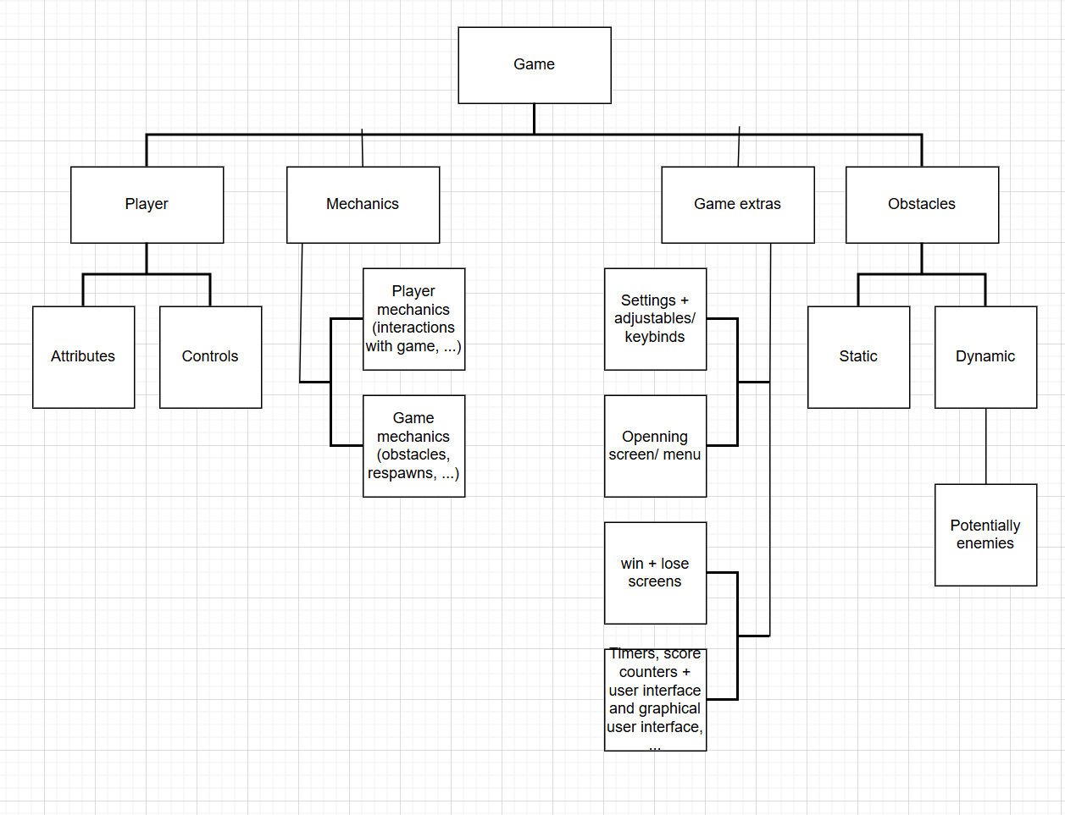

### Thinking Logically

This allows me to understand and plan out how to produce a solutions to each of my subproblems as broken down above in Thinking Procedurally. This might include game logic like how different obstacles function, as well how the player’s movement works:

* When a player jumps, they cant jump again until they fall onto a solid object, unless they have for example double jump (if double jump is implemented)
* When a player is harmed, their health is reduced by a certain amount, if they die, i.e health is seen to be 0, their lives counter is decremented by 1, and if lives counter is checked to be 0, they have to restart and a screen that displays their loss, score, how far they made it, etc. is displayed. Else if the player successfully beats the level, they see a win screen instead.
* When the assigned button is pressed (by default ESC), the menu screen will show, allowing the player to pause the game and choose other options that are outside the main game (like opening the settings).

### Thinking Concurrently

By thinking concurrently, I can identify issues with the current solutions and fix them. This is important since I know I will have a scoreboard and timer (a simple scoreboard and the sun that rises and falls to indicate timer), therefore I already know that I need these two features to be updated at the same time since as the player is obtaining score, the timer is also moving.

## Stakeholders

The game’s graphic design will be very similar to the three games mentioned earlier; arcade and retro style. This art style is simplistic and useful for my game because it ensures that players are more focused on the core gameplay rather than how the game looks. This is important since the point of the game is to improve problem solving skills, if the player is too distracted by a beautiful graphic design, they won’t be fully concentrated on solving the problems that are presented in the game. By having the player’s focus set on the core gameplay itself, the game will be able to more accurately assess a player’s current set of logical reasoning skills, and improve them more efficiently. The game is also intended for computer and laptops, this is because PC keyboards allow for flexible controls. Furthermore, a keyboard allows for a better approach to improving problem solving because if I were to implement mobile controls for example, I would have to use icons or decals to indicate what each control does, and this doesn’t really help the player in developing their mind because they will easily be able to tell what each control does, whereas forcing the player onto a keyboard where they don’t know what each key does, allows them to think about how they can use the keys to beat the game. Considering these factors, the game will be most suitable for audiences in the age group of 7 years to 18 years. This is because since the game is going to be available for PC only, and children of these ages are in school where computers are used more often, they will be able to play. The majority of children in this age group also likely already know the alphabet, so the keys on a PC keyboard will be understandable making them easier to understand which key does what (which will be explained in the tutorial of the game). Also, since some text is present in the game, the audience should be capable of basic reading which this age group should be capable of.

### Interview 1

I have chosen a friend who is an avid gamer to answer my questions for this interview. He is interested in a platformer game as the ones that already exist are mostly out of date.

For my first interview, I want to get down the core parts of the game, to get an idea of what features I should include, and some other ideas and issues that that my stakeholder would like me to address in my solution, like what kind of things my interviewee is looking for in a game, what makes it enjoyable and allows them to learn at the same time, and more. This first set of interview questions gives me an idea from the player’s perspective, what they need to be able to experience in order to be willing the play the game and use my solution.

Q = question asked (red)

A = answer given by interviewee (green)

Interview:

Q: For a video game, what is more important, the enjoyment you get out of it, or what you learn from it? Why?

A: what I learn from the game as many well built games teach lessons that can help us in life while still enjoying the game, for example I have played a game where you have to do mental math to calculate projectile trajectories called “war thunder”. This, although minor, has helped me practice mental arithmetic which is quite useful in daily life like going shopping.

Q: Do you think sound play is important when it comes to single player games? If so are they more important because they provide a lasting memory / reminder of the game, or do you find them important for the information you obtain from them in order to progress in the game?

A: I find the information I obtain from sound more important because I can use them to determine my next course of action. For example when I played slasher games before, certain sound queues informed me of if an enemy is attacking and what kind of attack it is, so I can plan out my next move. I don’t think it makes a lot of sense to listen to the sound in a game for the memories because in my opinion the sound is literally there to tell you what is going on.

Q: what about a game keeps you engaged and willing to continue playing after the first hour of playing it? What makes it addictive?

A: I think a vital aspect of a game that makes me want to keep playing is how many and the types of choices and options you can make as the player, I don’t like it if the game is really static and there is only one way of doing things, as I think this restricts the player from using their imagination and makes every playthrough very monotonic. The story is also pretty important to me because without an engaging story, I just feel like I’m playing a generic platformer, which I can do on any already existing platformer game.

Q: when it comes to graphics and visual effects, do you think these are more important than the core gameplay, or do you think both are equally important? Give reasons

A: I personally think they are equally important --- they actually depend on each other, like I think the better the core gameplay is, the more important the visual effects are since the graphics are there to bring life to the game and provide emphasis. If the game mechanics are good then surely good graphics would compliment the gameplay to make it more engaging and more refined. With that said, for simpler games like platformers I think the graphics aren’t too important, but they have to be satisfactory to the point where the graphics express the gameplay and game mechanics correctly such that the player knows what is going on in the game.

### Interview 2

For this interview I asked the same interviewee in interview 1. The objective of this interview is to determine what is aesthetically pleasing to see in video games, as if the graphics aren’t good enough, players will think that the game is of low quality and will be less engaged, as for example, if a game is just circles and blocks, it isn’t very interesting in this era because the circles and blocks don’t really bring any excitement.

This allows me to pick out how my game’s graphical design will work out. By doing this I can abstract what kinds of graphics from development and sounds a player would find plausible and appropriate for giving them information on what is going on in the game.

Interview:

Q: Do you think simpler sounds are better, or complex sounds for providing information to the player? Why? Do you think simpler means more distinguishable for example?

A: Simple because if they are too complex, that means the sound has too much to it which makes it harder for players to recognise them because there is more going on, by making it simpler, I think you could have more distinguishable and a larger variety, because if all the sounds had like a similar duration, then the player would also have less to memorise in order to recognise sound queues because they don’t need to worry about durations which means you can have the player encountering multiple events consecutively and have them still be able to react to what is going on. By making it complex the other issue I have is that it doesn’t really fit the tone of the game since I know it is going to be a platformer game.

Q: Do you think sound effects should be paired with visual effects to provide a better indicator of different events happening in the game, or do you think this shouldn’t be the case as it would make the game too easy? Why?

A: I think it should be well rounded because if there are too many visual effects, then it becomes painfully obvious to the player what is going on and takes away the contribution needed from the player to play the game, this means fewer chances for the player to learn and apply things they have learned which is the objective of this project. But I also think without enough visual effects, the gameplay will feel one-sided as the player is only relying on sound to react to certain things. Basically the visual effects should be subtle because they are easier to determine than sound.

Q: Do you think the mood and tone in the background /pathetic fallacy is important for setting the game’s tone and how the game teaches its lessons? Why?

A: I think there should be a bit of background tone to help with understanding the situation of each level, it also brings engagement as there is more going on and more for the player to inspect and think about, but again, if there is too much , it will end up causing problems like with the previous question, over do it and the player will be distracted and lose focus of the main objective, which defeats the purpose of the solution.

### Interview 3

For this interview I want to know more about any specific preferences and needs that my stakeholder wants in the game, like how they want to see their character behave, such as when they win on a level or when they lose, or when they perform different actions like when jumping for example.

Q: How would you like to see the character animated? (Jumping, losing, winning?)

A: For jumping I think both his arms should flail up to exaggerate it and show he is jumping, for losing I think if he dropped down to his knees and started crying would be a good way to animate it because it makes it very clear the player has lost, and for winning the opposite, have him get a crown on his head and hold a trophy while jumping.

Q: how many lives do you think you should have before you are reset to the beginning? Depending on your number, why do you think this? Do you think you picked the number of lives based on the difficulty that it has on the game and why?

A: I think that the number of lives should change depending on difficulty of level, so for the first few levels, start off with unlimited in the tutorial or first level so it’s fair and players can figure out what’s going on first before heading into the larger part of the game, then have them start the actual levels with 5 lives, as they get to harder levels give them slightly more so that there is still balancing, but at the same time enforces them to be cautious with how many lives they have to work with.

Q: what kind of sounds do you want to hear when the character performs certain actions (dying, jumping, running + walking, landing after jumping, etc)?

A: for dying I think he should yell or scream “ahhh” to make it clear to the player they died, for jumping maybe a hop noise, like similar to super mario games, for walking and running I think it should be simple footsteps that don’t interfere too much with the rest of the game’s sound so the player can still hear and react to other events going on. For landing maybe a grunt, anything simple for the movements in my opinion would do.

Q: do you think once the player loses all their lives should all their data be reset and they have to start again, or do you think they should only be reset to the first level but keep certain things, if the second option, why and what kinds of items do you think they should maintain?

A: I think there should be checkpoints on lower levels so that the player can get a better grasp of the game faster, so that every time they lose all their lives, they will drop back to a previous checkpoint in the last level and don’t have to start entirely from the beginning since that would be boring and locking players who cant make it past the easier levels permanently in the lower levels, but then once the player reaches the harder levels, every time they lose all their lives, they just get reset to the last checkpoint of the easier levels, so they can immediately start off with playing on the easiest of the harder levels, this will prevent players from being discouraged to try again every time their progress is wiped.

## Existing Solutions

One game that is already a solution to my problem is ‘Dead Cells’, it is a fighting-adventure game where the player traverses multiple levels each with a different kind of layout and obstacles, along with unique enemies in each level. At certain points of the game there are also bosses. The player must reach the end of each level (a door) before they can proceed to the next level. Each level also contains other points of interest such as item/collectible shops and secrets/easter eggs. The game is 2 dimensional and seen from the side of the player and involves the player collecting weapons and upgrades to defeat enemies easier. Some of the player’s base features are the ability to run, attack, jump, roll (a defensive option that provides something called ‘invincibility frames’ (i-frames) where while the i-frames are active the player takes no damage and “dodges” all active attacks landing on the player), sliding, and drop slamming (where the player can negate fall damage by accelerating while falling and slamming into the first horizontal platform they fall upon). There are also many obtainable features that the player can obtain and keep. Every time the player defeats an enemy, depending on the enemy, they will drop a reward for the player, usually this reward is a form of currency the player can use (cells, which are all lost on death by the player as well) but occasionally, the reward may range from collectibles to attribute upgrades to weapons. If the player dies, they lose almost all of their possessions and are reset to the very beginning of the game. This provides some form of reward but also punishment which forces the player to be smart about how they play throughout the game. The game also features a healing system where the player has a number of ‘healing flasks’ which they can drink to regenerate health points, and these flasks may be refilled in the intermission stage between levels every time they complete a level without dying, also enforcing a sense of strategy as player must conserve and use their flasks at suitable times.

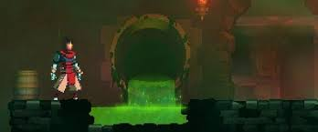

Acid pool in a 2nd layer level ‘Toxic Sewers’

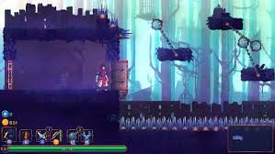

Swinging spike balls (dynamic obstacles)

Spikes

In the 2nd layer level ‘Promenade of the Condemned’

Above are two examples from the game. They are two separate levels and have different types of obstacles, in the first one acid pools are a kind of obstacle where if the player stays in them, they take damage over time, whereas in the bottom example, the obstacles distribute instances of damages for each time the player comes into contact with them. Below is an example of the player taking damage, a border with a fading red hue is seen to indicate to the player that they are taking damage, their player also flashes red.

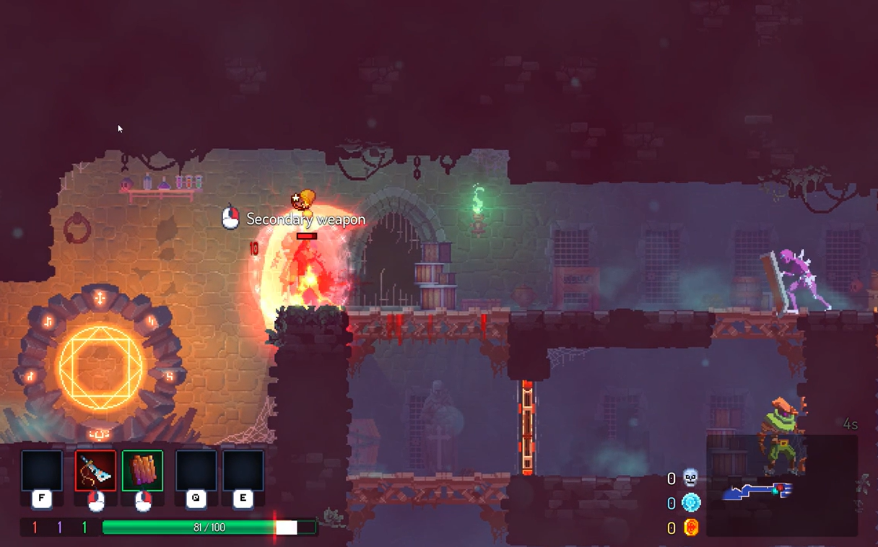

Player flashes red when hit, and the white shows the health that was lost when player was hit, the red vertical line shows where there health is now

If compared with the previous 2 images, you can see that the screen is redder here, this shows the player just took damage

Every time the player accomplishes something new, they are rewarded with an achievement as shown below:

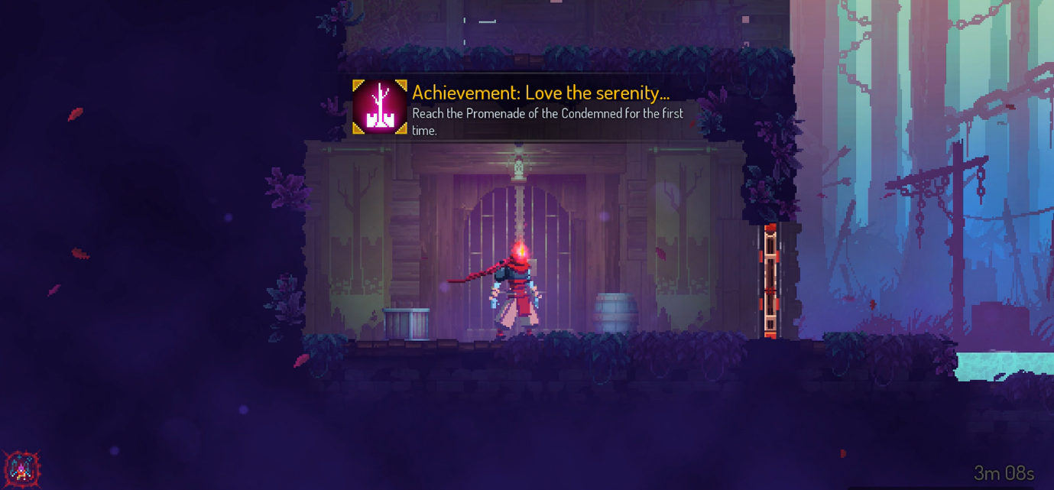

Achievement prompt

Everytime the player loses i.e dies in dead cells, their screen fades black and are displayed a message to tell the player that they lost and have to restart:

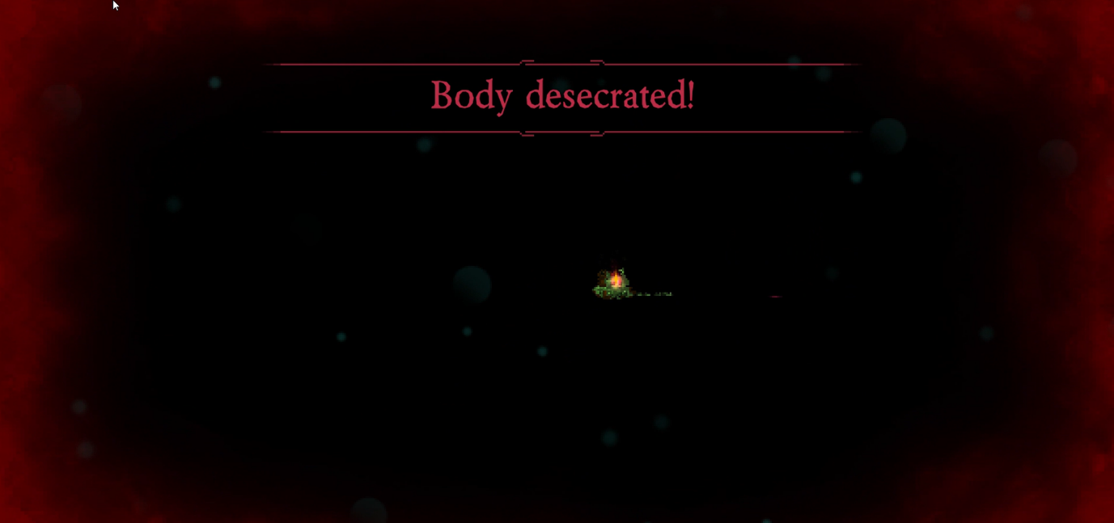

Lose message with emphasis as seen by the 2 red horizontal lines

Black screen

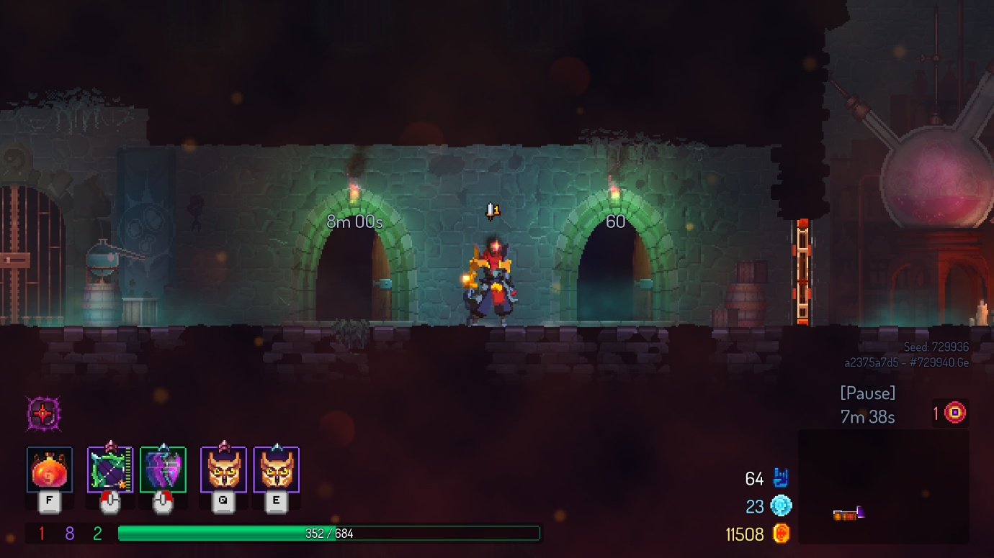

Dead Cells has a timer system, where certain levels reward the player for completing them in within a time limit

The above shows a feature in Dead Cells, timers, this provides a cut of difficulty which if the player is able to cope with, rewards them.

Below is a picture of the Dead Cells menu screen, it has many options which allows the players to pick what things they want to do, for example select difficulty, adjust settings, or play a daily challenge game mode.

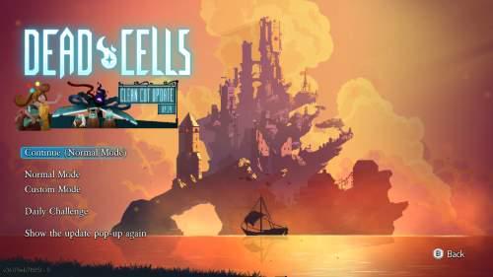

Other game modes

Play, with the selected difficulty

Game mode options, difficulties

A second existing solution is the Super Mario Bros. game. In this game the player plays through a story as either one of two characters. It is a classic platformer game and the player progresses by traversing each level, as they move the player’s screen shifts along to keep the character in view. Every time the player encounters a coin, if they touch it they receive the coin and that is incremented to their score on the top left of their screen, shown as a coin counter.

As mentioned earlier, Dead Cells also rewards players for defeating enemies or accomplishing certain tasks. These ‘drops’ or ‘collectibles’ may come in different rarities as shown below.

The player’s score (cells, the blue round icon) and the amount of currency they have below it

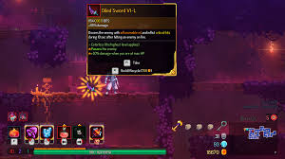

Item/drop description with different ‘pips’ which give the item a few extra, unique features such as the ability to poison enemies

The item drop itself, all items have some sort of glow around them to indicate that they can be picked up, different colours mean different rarities of items or different types. E.g yellow is legendary, red is for a certain class of weapons.



The world’s view follows the player as they move, so that they can continue to play through the map even if they are on a smaller resolution device

Every time Mario touches a coin, you can see the coin counter increases

The benefit of the world scroll is that the levels and maps in the game can be made as large as the developer wants to, if there was no world scroll players would be restricted to the field of view available from the resolution of their devices, which limits the content within the game.

The third solution to my game is trap adventure 2, which went a creative route for a platformer game and has many obstacles designed to behave differently depending on how the player plays. In terms of core gameplay, it is essentially the same as Super Mario Bros; the player travels through multiple levels, avoiding obstacles via parkour, once they reach the end of the level, they are brought to the next, unlike the previous two solutions however, trap adventure 2 is much more generous with lives to compensate for it’s difficult levels. The dynamic obstacles are hidden and only appear when the player fulfils certain conditions, below is an example of a hidden spike as well as a very generic but acceptable lose screen:



Simple but effective game over screen which clearly indicates to the player that they lost.

Only when the player gets close enough to the obstacle, do the spikes appear to knock the player off into the pit below.

Below are some examples of features from both Super Mario Bros and Trap Adventure 2 that I intend to use. These show the lives (tries/attempts left) and timer features respectively.

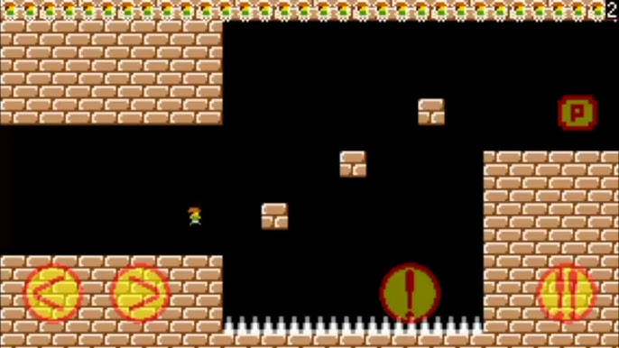

The small character images show how many lives the player has left.

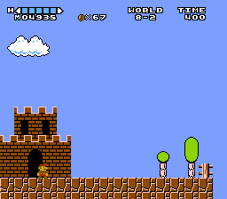

The top right corner has an indicator that shows how much time the player has left to complete the table

All 3 existing solutions also feature a settings feature which provides the player with the freedom to play the game with or without certain minor features:

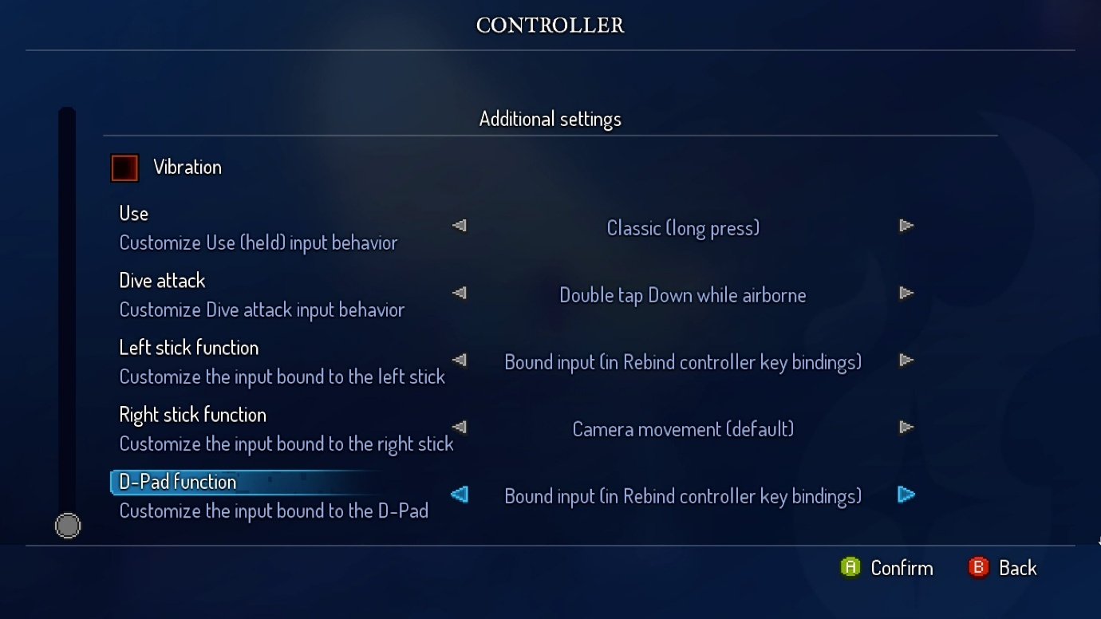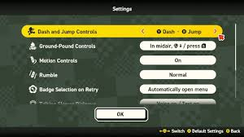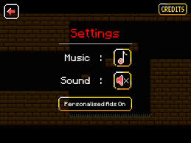

Dead Cells has the most freedom when it comes to settings, allowing the player to play the game in whatever way they want

Trap adventure 2 has a very simple settings as it needs to maintain game difficulty

Super Mario Bros’s settings provide certain quality of life options

## Essential Features

The features that should be completed as part of the original solutions will include:

* Static obstacles – spikes, lava / acid pools, spiked walls, …
  + This is so that there a basic obstacles that the player has to memorise on how to avoid, this will train their muscle memory which can then be used to help them think more efficiently, as once they encounter new dynamic obstacles, they will have a more procedural way of thinking up strategies to avoid the sentient obstacles, training their problem solving skills.
* Dynamic obstacles – disappearing platforms, hidden spikes, traps, …
  + These are meant to test the player’s logical thinking skills as they will always be made so that the obstacles cannot be avoided via playing the game brute force or by obvious methods, this way the player has to get creative and think about how to avoid them.
  + This idea has been taken from Dead Cells and Trap Adventure 2, which both have a great difficulty meter due to having dynamic obstacles
* Multiple levels that get harder
  + This provides a challenge to the player so that they can continue to improve their reasoning and also keep the players engaged with plenty of content.
* Settings
  + Includes key bind changes, and other generic settings a game would have like volume, potentially lighting, this way players who aren’t comfortable with the default game can change it to a certain extent without affecting core gameplay.
* Health and lives counter
  + This is an indicator for the players so they can keep track of how much health they have, and how many lives they have so they can be more or less cautious depending on how far away they are from losing.
  + I have taken inspiration from the 3 existing solutions, however have decided to adapt on Trap Adventure 2’s system because Dead Cell’s system is too harsh as players will lose the entire game immediately upon death, whereas in Super Mario Bros it is too generous.
* World scroll
  + World scroll is the camera view the player sees, so as they move throughout a level, they can see different parts of the map within the boundaries of their screen size, this allows for larger map / levels.
* Character with movement options and certain actions – running jumping walking
* Sound effects
  + Provides information to the player so they can use it to help them beat the game
* Score counter
  + An indicator that displays the player’s score so they know how far they are from beating a level in the best and most efficient way possible.

## Limitations

Extra features if the essential ones are successfully implemented well and there is enough time to add extra features:

|  |  |  |
| --- | --- | --- |
| Feature | Reason for it’s addition | Reason it’s a limitation |
| Bosses and enemies with special abilities to hinder the player’s playthrough | This would add a next level of difficulty to the game as well as bringing it more life. This way players have to both compete against obstacles that are premade in the level, and against computer which may act differently depending on the situation, forcing the player to adapt more. | The project has to be completed within a time limit and I don’t have sufficient knowledge and time to learn how to make a good quality artificial intelligence + pathfinding + decision making for enemies |
| Player abilities | They would bring the player more reason to play the game as children like to see cool abilities and visual effects. More importantly however it enables players to think creatively on how they can use the abilities to beat the game. | A bit pointless unless the above feature is added because the main point behind this idea is to deal with the enemies, for completing a platformer game it is more or less optional and the abilities’ side usage. |
| Create your own level game mode | This would give players who have completed the game and felt there is little replayability more reason to continue playing the game. It also encourages players to think creatively which in turn encourages and teaches other players who player community made levels to think creatively and learn different strategies. | This requires the game to be made multiplayer and I don’t have that much time to learn how to create a multiplayer feature because without this feature, there isn’t much point to playing your own level as you already know the layout of it. |
| Mobile inputs | It would enable a larger audience to be able to play the game | With the number of controls in the game, it wouldn’t be possible to add enough buttons on a mobile screen to ensure all the controls are covered, at least not without much of the screen being covered and unseeable for devices that are any smaller than an iPad. Due to the project also having a time limit I don’t have enough time to learn how to do this since I also have A levels. |

Hardware and Software limitations:

|  |  |  |  |
| --- | --- | --- | --- |
| Hardware/Software | Limitation | Reasoning | Reason it is a limitation |
| Hardware | There may be many obstacles and hidden ones on higher levels resulting in large memory cost and potentially slowing down performance | On harder levels there has to be more content as this is to ensure harder difficulty and players are tested sufficiently and effectively. | Not all players have access to high-end devices, including me as I am making this game on an old laptop that is also not in its best state. |
| Hardware | The game will only be accessible to devices with a keyboard | The controls will be made using keyboard keys which are easily implementable in visual studio code | Not all players will have a keyboard or a computer / laptop so it won’t be playable for them, I also can’t necessarily make a touch screen and mobile inputs feature because due to the time limit I am unable to learn how to make one |
| Software + Hardware | High quality lighting, visual effects and graphics | Especially for the targeted audience, children and teenagers, graphics are very appealing and may encourage more players to play | Pygame doesn’t exactly have the tools to make super high quality visual effects, even if I was able to draw very detailed map designs, it would also be problematic because that would be very GPU dependent and not all users will have access to this, including myself which makes testing also an issue |
| Software | Game sharing / Co-op game modes | Allows more people to play together which may be beneficial for promoting and advertising the game to a larger audience. | Visual studio code is better for writing code, it isn’t the best integrated development environment for producing games + the reasons from earlier (time restrictions) |

## Software and Hardware Requirements

|  |  |
| --- | --- |
| Hardware | Explanation |
| Computer type device (PC, laptop, … anything with a keyboard) | The controls are keyboards keys, and the players can’t make inputs and play the game if they cant access the controls. |
| Monitor/screen/output device | The game must be displayed to the player so they can see what is going on and what they are doing otherwise they won’t be playing the game. |
| 8-16GB of RAM | This is the average computer’s RAM capacity, since the game has a decent amount of obstacles and content (drawings, map designs, etc.), the player’s computer must be able to handle this without crashing so the game can run smoothly |
| 1.6GHz processing speed or above | Minimum requirement for visual studio code to run, if they can’t open visual studio code, they can’t execute the code to play the game |
| 1GB of secondary storage | Sprites will be used in the game, but there may be quite a lot of them for the character, obstacles, maps (as modules are going to be used), and more. The large secondary storage is to ensure for this game that no matter what content is in it, there is enough secondary storage to support it. |
| Output device (headphones, speakers, earphones, etc.) | The game has sound effects, so the player needs to be able to hear them to get information on what is going on in game. |

|  |  |
| --- | --- |
| Software | Explanation |
| Visual studio code | The game is written in VS code IDE, to run it the player imports the game’s files and runs them in VS code, allowing them to play it |
| Pygame library | Most of the game’s code is written using pygame’s library, so the player can run the game as their computer can then understand what the game’s code is instructing to do. |

## Success Criteria

|  |  |  |  |
| --- | --- | --- | --- |
| Number | Criteria | Explanation | Reference |
| 1 | Opening screen | To show player the game has started up | Feature in all 3 existing solutions. |
| 2 | Static obstacles | Standard, obstacles for players to overcome, must have in a platformer game like this | Dead Cells obstacles |
| 3 | Dynamic obstacle | Obstacles that require more critical thinking and require a strategy to get around | Trap adventure 2 feature, interview 1, the stakeholder likes a game having more difficulty, Dead Cells obstacles |
| 4 | Levels with different map designs | Brings variety and a form of progression to the game, so it has a story and can be played for a good amount of time before the game is completed |  |
| 5 | Controllable player with movement | It is a platformer game so the player has to be able to navigate the game somehow |  |
| 6 | Menu + Settings | To allow the player to change parts of gameplay to their liking, and to accommodate for certain player’s circumstances, like people who may have certain keys on their keyboards that don’t work so they can re bind controls |  |
| 7 | Health + lives system | Provides a permanent-death system which in turn enables a sense of difficulty and forces players to plan out and strategise how they play the game safely | Interview 3, trap adventure 2 feature |
| 8 | Loss + win screen | Provides the player with a sense of achievement for completing parts of the game and encourages them to play on | Dead cells feature (loss screen), interview 3 |
| 9 | Respawn system | Linking to 8, the player has to be able to continue playing after they lose all their lives. | Interview 3, Super Mario Bros, Trap Adventure 2 |
| 10 | Timer | Provides difficulty, as the project aims at training problem solving skills, efficiency is also paramount, this allows the game to take the players’ critical thinking skills to the limit | Dead Cells feature, Super mario bros features |
| 11 | Tutorial mode | Teaches player the basics and how the game works, players cant play the game if they don’t know what it is |  |
| 12 | Background designs | Expresses the difficulties of different levels, encourages players to determine the difficulty since if they were just told, it would be too easy |  |
| 13 | Collectibles/obtainable items | Allows players to obtain achievements essentially, a reward system otherwise players will think the game isn’t worth playing | Dead Cells |
| 14 | Sound effects | Provides information to the player on what is happening in game, useful for helping players strategise | Interview 1 and 2 |
| 15 | World scroll | Important to allow larger maps and levels to be created and played by players, as it would be hard to fit a large level into a tiny screen, which makes small details undetectable. Without this players would see the whole level on one screen that doesn’t move and the character of the player will likely be very small to be seen, making the game harder to play than it already is | All existing solutions |

# Design Stage

## Decomposition

## Structure

## Algorithms / potential solns

## Variables, Data structures, Classes

## Test Data

## Extra

# Implementation Stage

## Stage 1

In this stage, I will start off by making the base mechanics of the game. This includes:

* Basic movement controls (w, a, s, d, spacebar, etc)
* Collisions
* World side scrolling camera on movement
  + Player is centre locked
  + When moving in a direction, the objects on screen are moved relative to the player’s movement, if a boundary Is nearby, and the player moves toward boundary, the camera doesn’t exceed the boundary.
* Some game states including:
  + Menu on startup
  + Settings button + settings
  + Quit button that ends the game
* Respawning + live/health system
* Level end blocks (to finish the level)

## Stage 2

## Stage 3

# Testing Stage